**Sequence Diagrams of the Use Cases**

1. Enter Student ID# and Validate ID#

Objects

* Scanner
* MealCardDB (Meal Card Database)

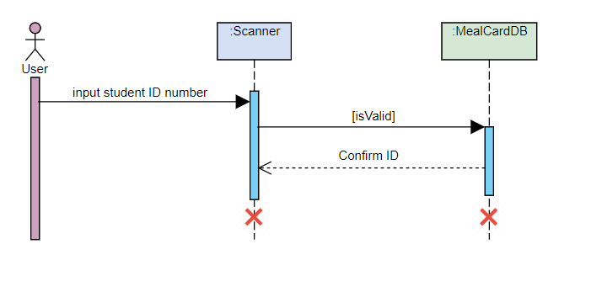

1. Attain amount on card, if none assign

Objects

* Scanner
* MealCardDB

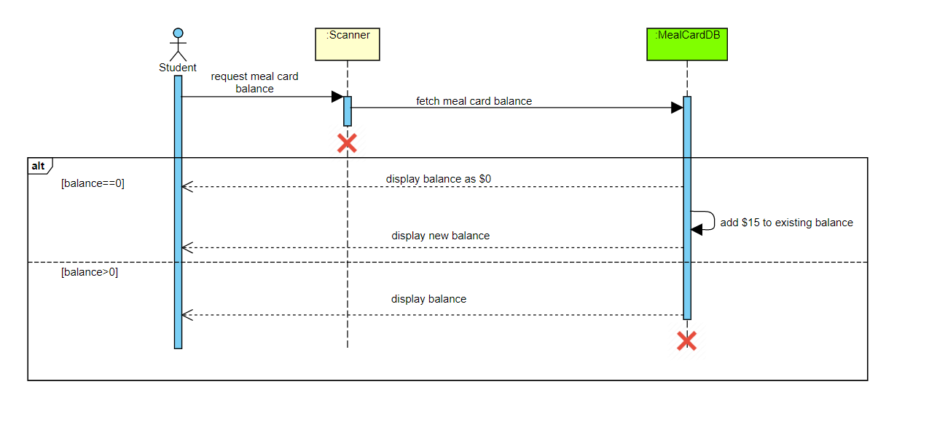

1. Retrieve updated menu and pricing

Objects

* Scanner
* Menu_Pricing

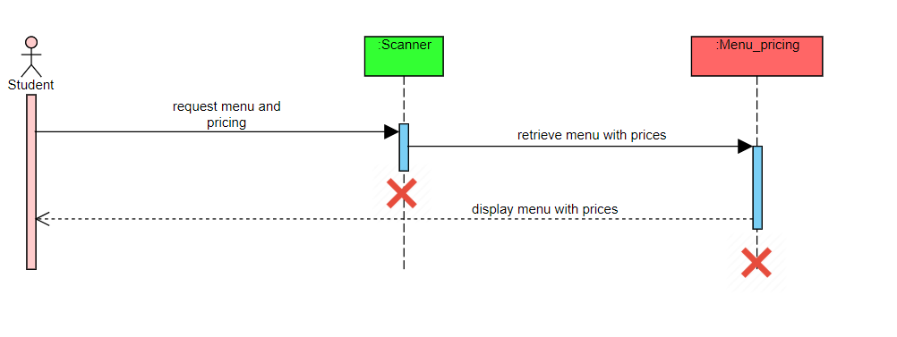

1. Make a selection of items and keep track of total

Objects

* Scanner
* Menu_Pricing

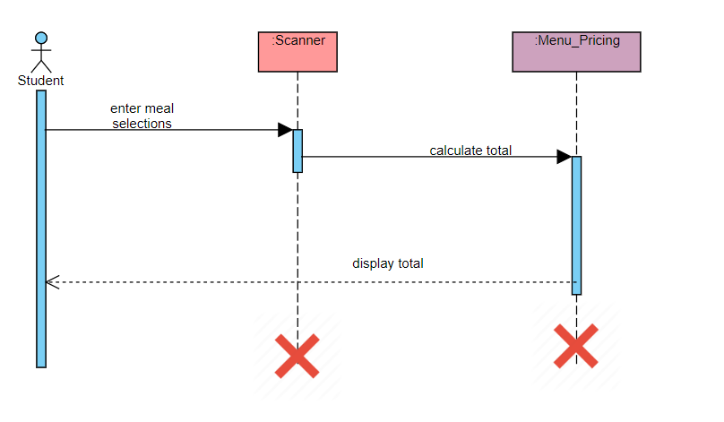

1. Retrieve remaining meal card balance

Objects

* Menu_Pricing
* MealCard DB

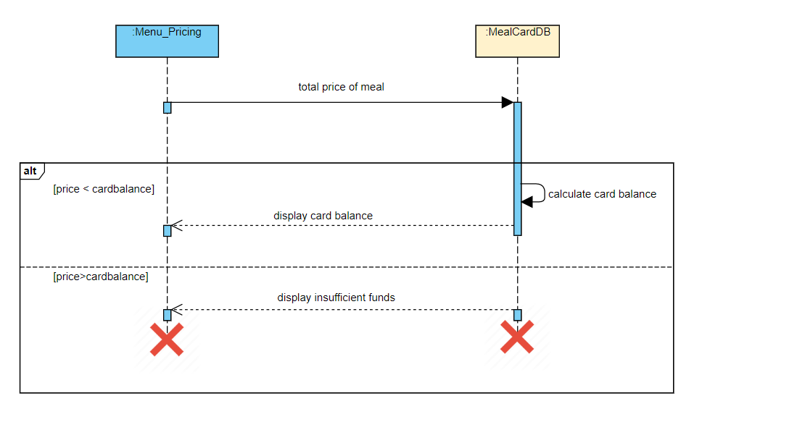

State Diagram for Scanner object and Student class object

Object: Studentclass

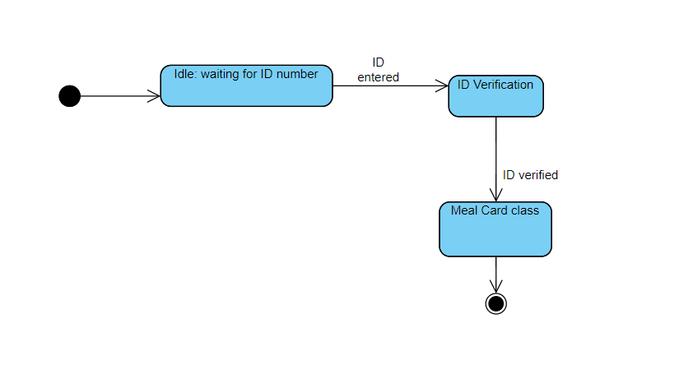Object: Scanner

Object: Scanner

